NUST

NATIONAL UNIVERSITY OF SCIENCE AND TECHNOLOGY

**A Basic Review of Open Source E-Commerce Solution**

**PrestaShop**

**By: Eiman Fatima**

Table of Contents

**Table of Contents**…………………………………………………………………………2

**Introduction**……………………………………………………………………..3

**Installment**..………………………………...……………………………………3

**User perspective**………..………………………………………………………...4

**DB developer and Coder perspective**…………………..…………………………7

**Plug Ins……**………………………………………..……………………………9

**Exploring Open Source Software**



**Introduction:**

PrestaShop is an open source e-commerce solution. This software has open source license. It is written in PHP language with the support for MySQL database management system. PrestaShop can be used on the local server as well as a web server.

**Installment:**

To develop an e-commerce website, first we need to install the PrestaShop on a local server like wamp or xampp.

During the installment, the system asks for the email and password for the admin that will be used for the login of the admin.

System will get the name and the specifications of the product that the website will deal with. The system will make a database and the required files for the proper functioning of the system.

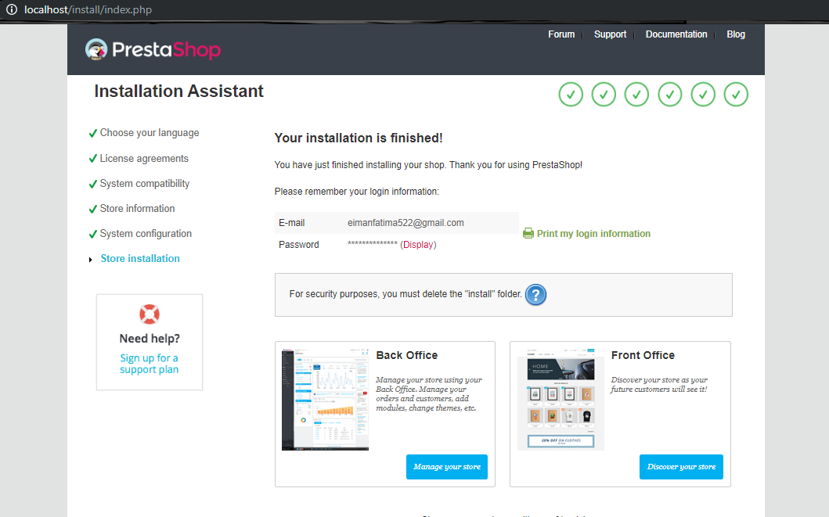

Figure 1: Installation

***User Perspective***

PrestaShop gives user two options for their website. **Front Office** and **Back Office.**

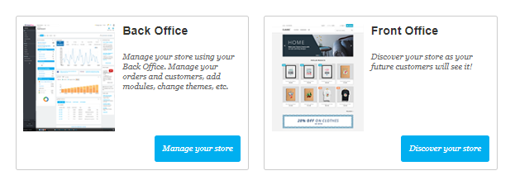

Figure 2: Main page

The Front Office is basically related with the interface of the website that the admin has specified. The items that are provided by the seller, their prices and specifications are available here. The user can login or Sign Up into the website and maintain their items list in the Cart. This is the interface that will be available to the user who is using the website for online shopping.

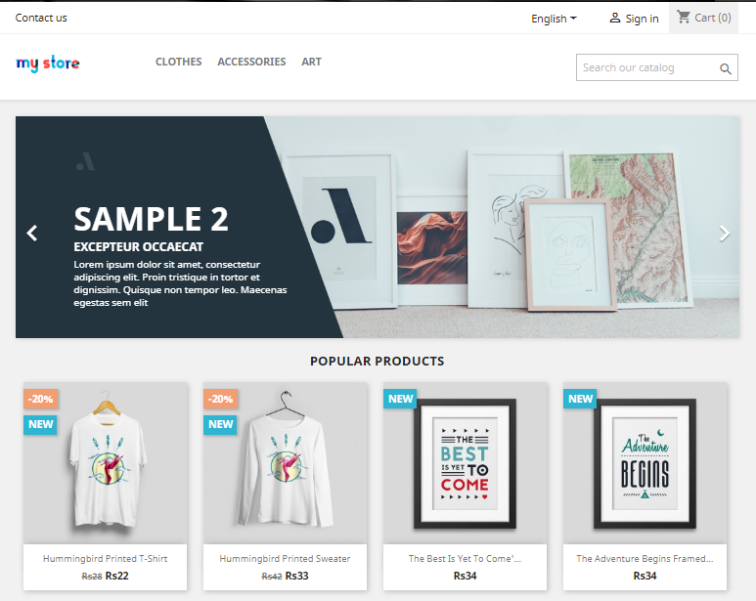

Figure 3: Front Office

**Back Office** is the back-end mechanism that the admin will use for setting the catalogue of items and other functionalities explained below

**1. Catalogue Management**

This is related to the products and categories that are available in the store and the website. This can be further classified into following classes.

**Product** can be used to view to already existing products, adjusting their prices, searching by categories and maintaining the number of the products in the inventory. Another feature is that we can add new product in the database, specify its price and other specifications.

**Categories** are used to specify the category for the products e.g. Disabled, Customized and Animated etc. This categorization is done so that bulk actions can be taken on the products instead of applying changes to ever single product.

**Monitoring** is used to keep a check on the empty categories and the number of items available and their quality.

**Attributes & Features** deals with the size, color and dimensions like features of products.

**Brands** are used to specify which brands are supplying products to the seller.

**Files and Discounts** keeps track of the data files and the discounts that can be given on a product.

**2. Customer**

This category is used to maintain the data of the customers who are using the website. This data include their names, ages, last visited date, registration date, postal addresses and the email addresses.

**3. Customer Services**

This area deals with the order messages, error reporting, returning of the products and the refund of the money

**4. Order**

The orders, invoices, credit slips, delivery methods and the shipping process is handled in this domain.

**5. Statistics**

The availability, prices, stock rate, best-selling products and the top searches are maintained in this sector. This information is used to predict the future orders and trends. Depending on these results the company profit is plotted.

There is also the option for the **improvement** in all the services that are provided by the website to the user and the admin.

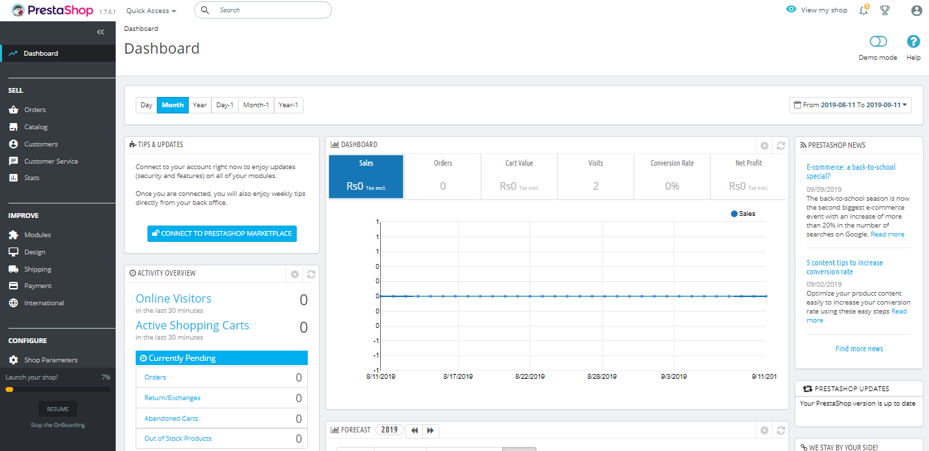

Figure 4: Back Office

***Database Developer and Coder Perspective***

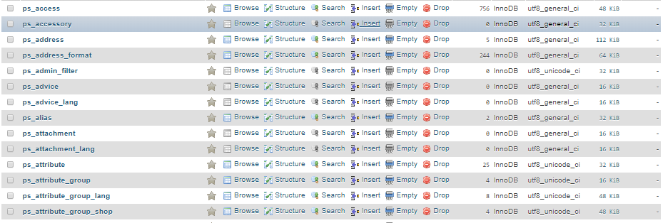

Figure : database tables

The database of the desired store is made by the PrestaShop with the tables of different entries of the shop like categories, addresses, admins, suppliers, manufacturers, brands, orders, deliveries, employee information, customer information, featured products, passwords and user name of the signed in users or regular users of the website.

We are given different options on what to do with these tables. For example we can add new values in the data like when a new customer signs in we can store their name, emails and passwords. We can also clear all the records in the table or a single entry from it. We can also delete an entire table from the database when it is no longer needed. There is also the option for the changing of structure of a particular table to add our desired columns or attributes.

For example in the address table the hypothetical values added by the PrestaShop are

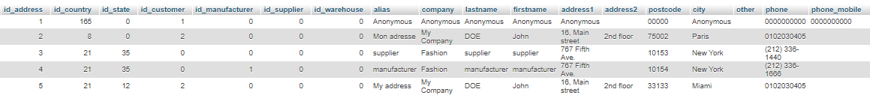

Figure : Table created by PrestaShop

We will delete all these values and change the structure as well. The new structure of the table that we made looks like below

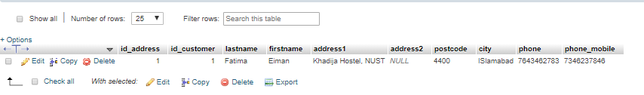

Figure : New table created by user

The coding of the store involve the **style sheets, JavaScript event handlers, DOM objects** and the **connection to the databases**.

As a coder we can easily make changes to the interface of the website. Most of the **coding** for the ordering and viewing the products are already done by the PrestaShop. A little changes can be easily done in the source code like showing the pop ups after the customers had placed the orders.

We can changes the **colors, fonts and the size** of the different objects that are appearing on the screen to make our website more exciting and interactive. User can provide their information by logging in by any account or make their own account on the website if they are going to use it more often.

There are different **JS Event Handler** in action to make the website more interactive. Event handling can be done in the separate JavaScript file and attached to the source code easily.

The basic handlers are

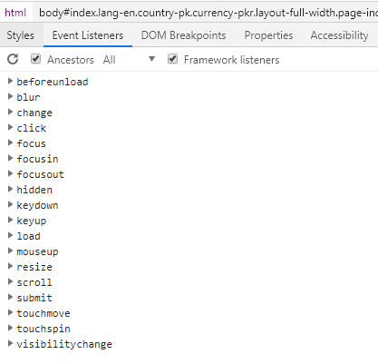

Figure 8: Event Handlers

Every handlers has a specific function that it performs when triggered which is performed by the website. We can add new handlers or simply make changing to the functions of these event handlers in the source file. This wide range of the resources provides a framework or structure to the coder to design a website and make little changes according to their taste and likes to make website more exciting and interactive

***Plug INs:***

PrestaShop has wide range of built-in modules. We can also download and install new modules from the website of PrestaShop to add new functionalities to our website.

To do this, first we will download the zip folder of the module available on the website then in the back office in module folder we will upload the zip folder and install it. This simple procedure can be used to add desired number of modules to the website. There are free as well as paid modules available for PrestaShop.

The products that are shown in the shop are in 2D as shown below.

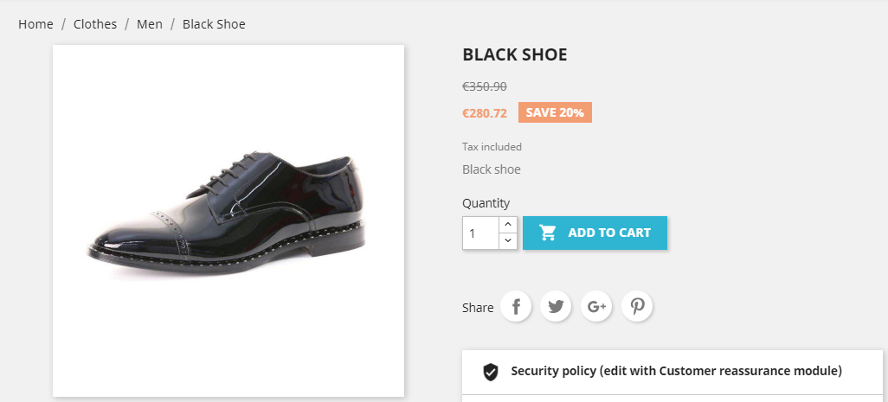

Figure : 2D view of product

We can download the module **Cappasity 3D and 360 Product Viewer** to get a 3D image of our product to get a clear idea of how our product looks and check the minor details of the product.

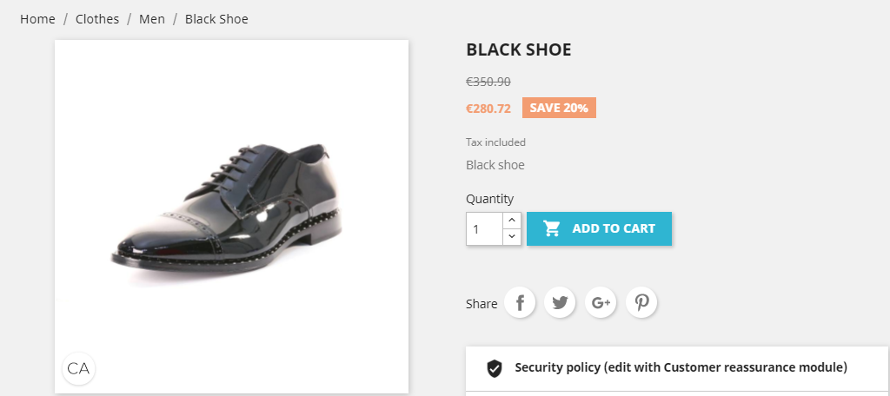

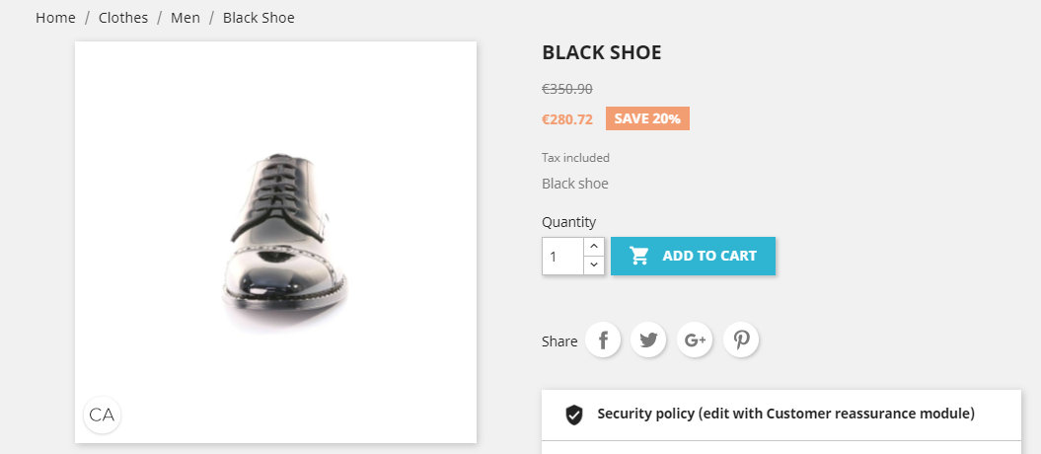

Figure , 8: 3D view of product